WEB TECHNOLOGIES LAB
LAB-1
REG.NO:181FA04363-3F
1.Aim
To Create a HTML document to display your profile and Class timetable to demonstrate lists, links, images, pre, font, heading tags.

DESCRIPTION:
A Table is an arrangement of rows and columns. Anyone can create a table by knowing the basics of HTML(HyperText Markup Language). A table is defined by using <table> tag in HTML.
ALGORITHM:
Steps to Create a Table:
- Create a <html> tag.
- Create a table using the tags <table></table>.
- Create rows in the table using <tr>This is the row tag</tr>.
- Insert the data into rows using <td> Table Data</td> tags.
- Close the table tag.
- Close the html tag </html>.

Source Code:
<html>
<head>
<title>My Bio</title>
</head>
<style>
table,th,td{
border:1px solid black;
}
</style>
<body>
<h2><center> SHORT BIO</center></h2>
<h3>About Me:</h3>
<img src="https://mail.google.com/mail/u/0?ui=2&ik=1bb04c9a3f&attid=0.1&permmsgid=msg-a:r8832388943339637061&th=17507dfb04fd78c5&view=att&disp=safe&realattid=17507df993edc9bb9481" alt="Girl" width="140" height="200" align="right">
<p> Hello,Myself M.Akhila Jyothi, </p>
<p>I am pursing my B.Tech 3rd year in Department of CSE in Vignan's University.</p>
<p>Father's Name: M.Venkata Ramana</p>
<p>Mother's Name:M.Padmaja</p>
<h5>ADDRESS</H5>
<pre>D-NO:4-96
Near Old Andhra Bank,Main Road
Bhattiprolu,
Guntur(DT).
</pre>
<hr>
<h2>Personal Brief:</h2>
<p>Email:akhilajyothimaddula@gmail.com</p>
<p>Contact:7675870401</p>
<p>Areas of Interest:Web Designing,Software Developer</p>
<hr>
<h2>Acquiring skills</h2>
<ul>
<li>Programming Languages
<ul>
<li>C</li>
<li>C++</li>
<li>Java</li>
<li>Python</li>
<li>HTML</li>
</ul>
<h3>Educational Qualifications:</h3>
<table>
<tr>
<th>S.NO</th>
<th>Course</th>
<th>Institutions</th>
<th>Duration of Study</th>
<th>Percentage</th>
</tr>
<tr>
<td>1</td>
<td>B.Tech CSE</td>
<td>VIGNAN'S UNIVERSITY</td>
<td>2018-2022</td>
<td>88%
At the end of 4th semester</td>
</tr>
<tr>
<td>2</td>
<td>Intermediate MPC</td>
<td>NARAYAN JUNIOR COLLEGE</td>
<td>2012-2018</td>
<td>94%</td>
</tr>
<tr>
<td>3</td>
<td>SSC</td>
<td>V.S.E.M.HIGH SCHOOL</td>
<td>2015-2015</td>
<td>9.7</td>
</tr>
</table>
<h4> You can find me more @<a href=file:///C:/Users/Akhila%20Jyothi/OneDrive/Documents/Bio.html>CLICK HERE</a></h4>
</body>
</html>

OUTPUT:

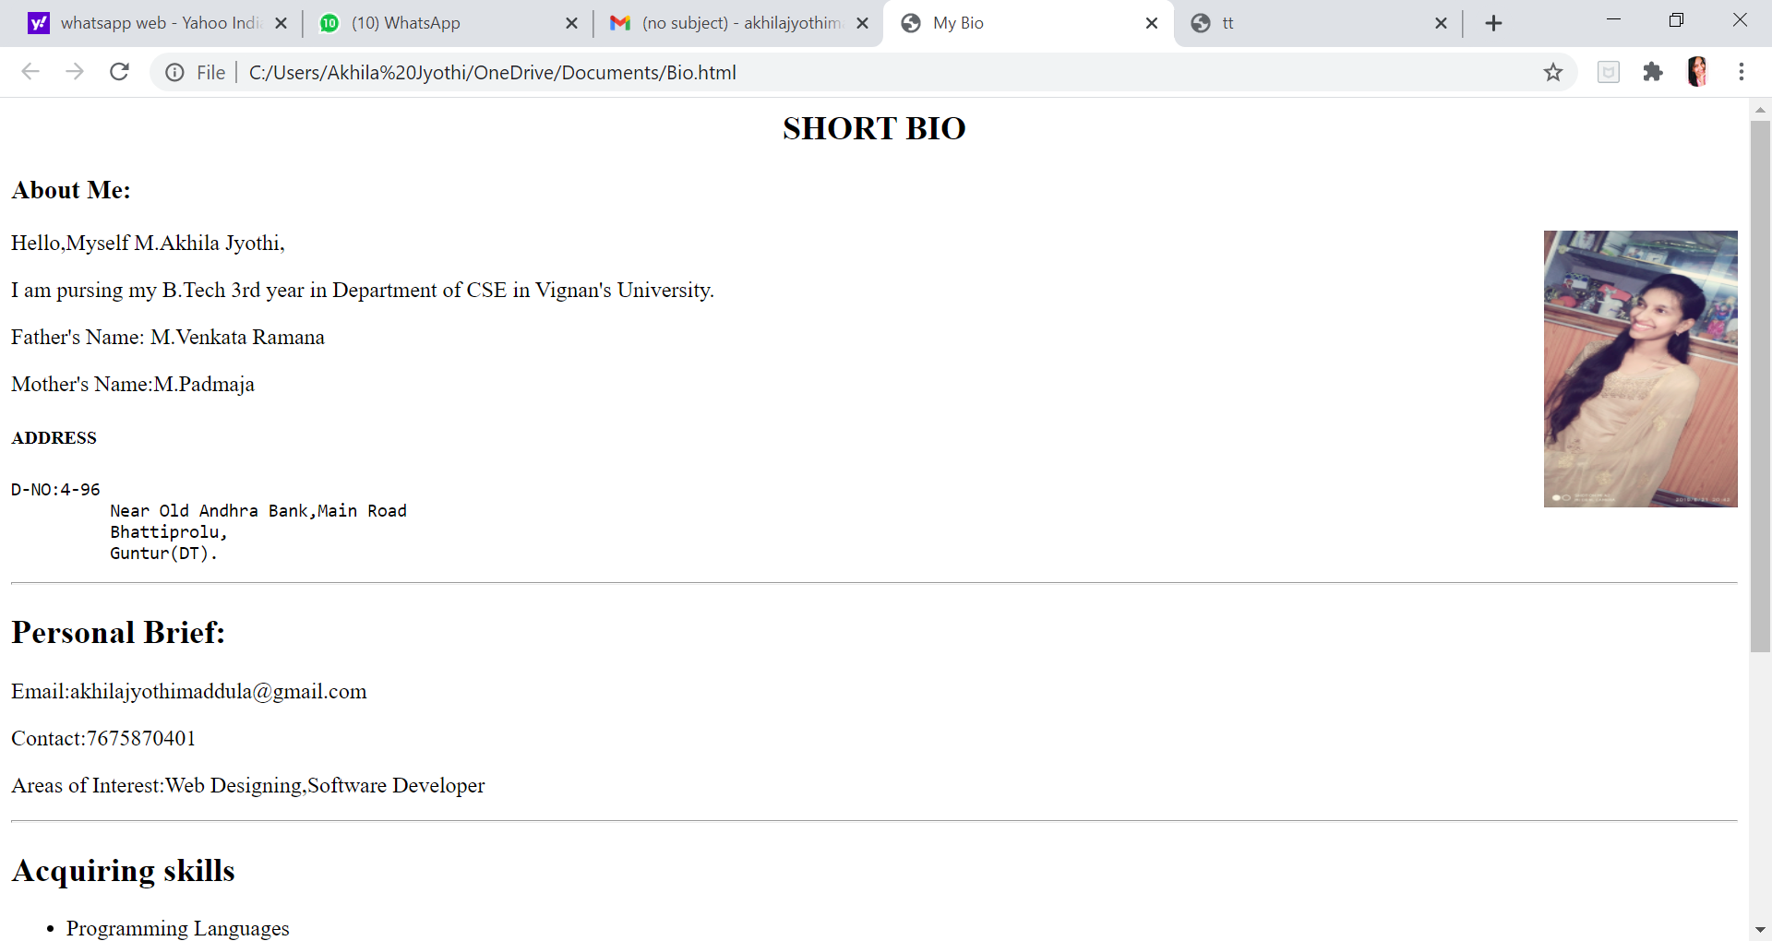

DISPLAYING TIMETABLE:
SOURCE CODE:
<html>
<head>
<title>tt</title>
</head>
<body>
<table border="1">
<tr bgcolor="green">
<th>Day</th>
<th>8.00-8.55</th>
<th>8.55-9.50</th>
<th>9.50-10.10</th>
<th>10.10-11.05</th>
<th>11.05-12.00</th>
<th>12.00-12.55</th>
<th>12.55-1.55</th>
<th>1.55-2.50</th>
<th>2.50-3.45</th>
</tr>
<tr>
<td bgcolor="green">Mon</td>
<td colspan="2" bgcolor="plum"> weeklytest</td>
<td rowspan="6" bgcolor="deeppink">BREAK</td>
<td bgcolor="yellow">WT</td>
<td bgcolor="pink">OSWT</td>
<td bgcolor="gold">CN</td>
<td rowspan="6" bgcolor="deeppink">LUNCH</td>
<td bgcolor="lightsteelblue">CD</td>
<td bgcolor="gold">CN</td>
</tr>
<tr>
<td bgcolor="green">Tue</td>
<td bgcolor="pink">OSWT</td>
<td bgcolor="yellow">WT</td>
<td rowspan="5" bgcolor="cyan"> Minor</td>
<td bgcolor="bisque">OS</td>
<td bgcolor="lightsteelblue">CD</td>
<td bgcolor="gold">CN</td>
<td bgcolor="yellow">WT</td>
</tr>
<tr>
<td bgcolor="green">Wed</td>
<td bgcolor="pink">OSWT</td>
<td bgcolor="bisque">OS</td>
<td bgcolor="lightsteelblue">CD</td>
<td bgcolor="steelblue">CNLAB</td>
<td colspan="2" bgcolor="steelblue">CNLAB</td>
</tr>
<tr>
<td bgcolor="green">THRU</td>
<td bgcolor="gold">CN</td>
<td bgcolor="yellow">WT</td>
<td bgcolor="bisque">OS</td>
<td bgcolor="tan">WTLAB</td>
<td colspan="2" bgcolor="tan">WTLAB</td>
</tr>
<tr>
<td bgcolor="green">FRI</td>
<td bgcolor="bisque">OS</td>
<td bgcolor="lightsteelblue">CD</td>
<td bgcolor="pink">OSWT</td>
<td bgcolor="violet">OSLAB</td>
<td colspan="2" bgcolor="violet">OSLAB</td>
</tr>
<tr>
<td bgcolor="green">SAT</td>
<td colspan="2" bgcolor="lightgreen">ACTIVITIES</td>
<td colspan="2" bgcolor="lightgreen">ACTIVITIES</td>
<td bgcolor="palevioletred">SEMINAR</td>
<td bgcolor="thistle">COUNSELLING</td>

</tr>
</table>
</body>
</html>
OUTPUT:

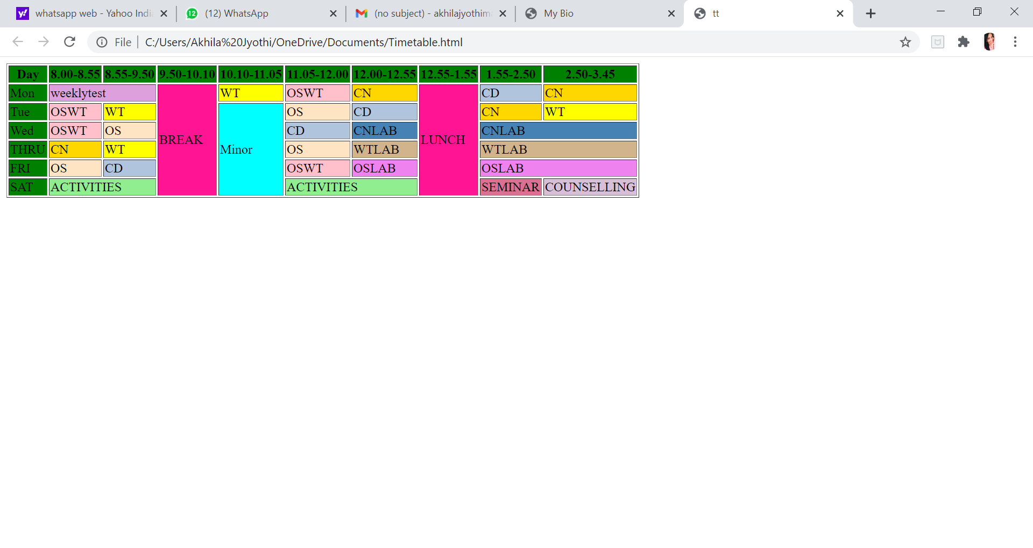

2. AIM:
To Create an HTML page having Four frames named
a. Top
b. Center
c. Bottom
d. Left
The Top frame should contain company logo and title. The bottom frame should contain copy right information. The Left frame should contain various links like Home, Products, Services, Branches, About us, etc. When we click on those links, the contents should come in to Center Frame.
DESCRIPTION:
HTML frames are used to divide your browser window into multiple sections where each section can load a separate HTML document.
A collection of frames in the browser window is known as a frameset.
The window is divided into frames.
<frameset> tag used to divide the window into frames.
The rows attribute of <frameset> tag defines horizontal frames and cols attribute defines vertical frames.
Each frame is indicated by <frame> tag and it defines which HTML document shall open into the frame.
SOURCE CODE:
Top.html:--
<html>
<head>
<title>VIGNAN UNIVERSITY</title>
</head>
<body align="center" bgcolor="gold">
<image src="logo.jpg" height=100px width=500px border="2">
</body>
</html>
Center.html:--
<html>
<body bgcolor="cyan">
DEPARTMENTS:-<br>
1. CSE<br>
2. EEE<br>
3. ECE<br>
4. CIVIL<br>
5. MECH<br>
6. BIOTECH
</body>
</html>
Bottom.html:--
<html>
<head>
<title>VIGNAN UNIVERSITY</title>
</head>
<body bgcolor="silver" align="center">
**Copyright © Vignan's Foundation for Science, Technology and Research (Deemed to be University) 2016. All rights reserved.**
</body>
</html>
Left.html:--
<html>
<head>
<title>VIGNAN UNIVERSITY</title>
</head>
<body bgcolor="yellow"/>
<a href="profile.html" target="middle">profile</a><br>
<a href="attendance.html">Attendance</a><br>
<a href="Internals.html.html">Internal Marks</a><br>
<a href="final.html">Final Marks</a><br>
<a href="od.html">OD</a><br>
<a href="logout.html">Logout</a>
</html>

Main Code:--

<html>
<head>
<title>VIGNAN UNIVERSITY</title>
</head>
<frameset>
<frameset rows="25%,*,10%">
<frame src="top.html">
<frameset cols="10%,*">
<frame src="left.html">
<frame src="center.html">
</frameset>
<frame src="bottom.html">
</frameset>
</head>

OUTPUT:
